|  |  |  |
| --- | --- | --- |
| American University of SharjahSchool of Engineering Computer Engineering Department  P. O. Box 26666 Sharjah, UAE |  | Instructor: Dr. Tamer Shanableh **Lab Instructor**: Eng. Sameer Alawnah  **Office**: EB2-101  **Phone**: 971-6-515-2974  **e-mail**: salawnah@aus.edu  **Semester**: Fall 2016 |

**CMP 220L – Introduction to Computer Science II**

**Pointers**

**LAB 1**

**Objectives:**

Completing this lab; the student will be able to:

* Understand the different pointers access methods.
* Understand passing pointers to functions.
* Understand passing arrays to functions as pointer.

**Question 1:**

Create an array of 10 elements then use pointers to do the following:

1. use travelling pointer notation technique to initialize the array
2. use pointer-index notation technique to print the array
3. use pointer-offset notation to find the maximum value of the array
4. print the address of each cell

#include <iostream>

using namespace std;

void main()

{

int arr[10];

int *ptr;

int max =0;

ptr = &arr[0];

int *add;

add = ptr;

cout << "please enter 10 values in the array:" << endl;

for (int i = 0; i < 10; i++)

{

cin >> *ptr;

ptr++;

}

ptr = add;

for (int i = 0; i < 10; i++)

{

cout << "ptr [" << i << "] = " << ptr[i] << endl;

}

for (int i = 0; i < 10; i++)

{

if (*(ptr + i) > max)

{

max =*(ptr + i);

}

}

cout << "The maximum value = " << max << endl;

cout << "The address of each cell: " << endl;

for (int i = 0; i < 10; i++)

{

cout << "ptr["<<i<<"] = " <<&ptr << endl;

}

}

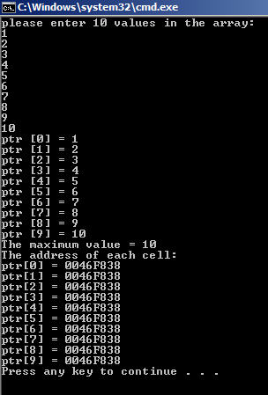

**Question 2:**

Write a program to reverse the content of an array of double values using two traveling pointers. Your program should create an array of 10 elements, read their values from the user, reverse the array and print the reversed array.

#include <iostream>

using namespace std;

void main()

{

double arr[10], temp;

double *ptr1, *ptr2;

ptr1 = &arr[0];

ptr2 = &arr[0];

cout << "please enter 10 values in the array:" << endl;

for (int i = 0; i < 10; i++)

{

cin >> *ptr1;

ptr1++;

}

ptr1--;

for (int i = 0; i < 5; i++)

{

temp = *ptr1;

*ptr1 = *ptr2;

*ptr2 = temp;

ptr1--;

ptr2++;

}

ptr1 = arr;

cout << "The reverse values: " << endl;

for (int i = 0; i < 10; i++)

{

cout << "ptr [" << i << "] = " << *(ptr1+i) << endl;

}

}

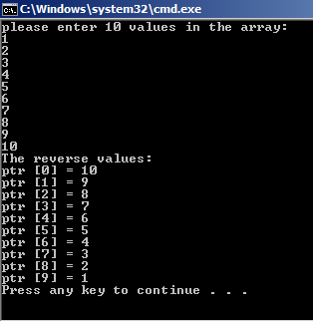

**Question 3:**

Write a program that dynamically creates an array of 5 integers, read them from the user and print them, your program should ask the user for the new array size which should be greater than the current size, then increase the size of the array and ask the user to fill the new elements and finally prints all elements in the array.

Note: To increase the array size, your program should create a pointer which points to a dynamically created new array with the new larger size and copy values from the old array to the new array, delete the old array and make the array pointer to point to the new memory

#include <iostream>

using namespace std;

void main()

{

int*ptr1 = new int[5];

int size;

cout << "please enter the values of the array: " << endl;

for (int i = 0; i < 5; i++)

{

cin >> *(ptr1+i);

}

cout << "please enter the new size of the array: " << endl;

cin >> size;

int *ptr2 = new int[size];

for (int i = 0; i < 5; i++)

{

*(ptr2+i) = *(ptr1+i);

}

delete[]ptr1;

ptr1 = NULL;

cout << "please enter the values of the new array: " << endl;

for (int i = 5; i < size; i++)

{

cin >> *(ptr2 + i);

}

cout << "The new array = " << endl;

for (int i = 0; i < size; i++)

{

cout << "ptr [" << i << "] = " << ptr2[i] << endl;

}

delete[]ptr2;

ptr2 = NULL;

}

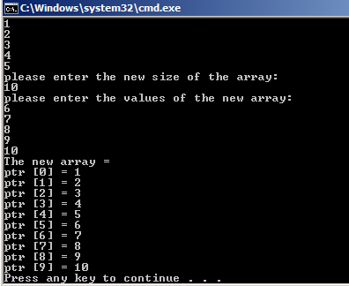

**Question 4:**

Write a program that creates a 2D array of integers as the following:

const int ROWS=5;

int* array[ROWS];

Your program should ask the user to enter the number of columns, fill the array using user input and prints the average for each row and the average for each column.

#include <iostream>

using namespace std;

void main()

{

const int rows = 5;

int **array = new int*[rows];

int csize, csum=0, cavg, rsum=0, ravg;

cout << "Please enter the number of columns: " << endl;

cin >> csize;

for (int i = 0; i < rows; i++)

{

array[i] = new int[csize];

}

cout << "Enter the value: ";

for (int i = 0; i < rows; i++)

{

for (int m = 0; m < csize; m++)

{

cout << "array [" << i << "][" << m << "] = ";

cin >> array[i][m];

}

}

int m;

for (int i = 0; i < rows; i++)

{

for ( m = 0; m < csize; m++)

{

csum = csum + array[i][m];

}

cavg = csum / csize;

cout << "The average of column = " << cavg << endl;

csum = 0;

}

for (int i = 0; i < csize; i++)

{

for (m = 0; m < rows; m++)

{

rsum = rsum + array[m][i];

}

ravg = rsum / csize;

cout << "The average of row = " << ravg << endl;

rsum = 0;

}

}

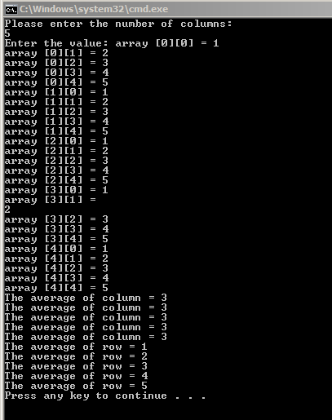

Good Luck ☺